**Driver Drowsiness Detection System Using Arduino**

Robotics Mini Project

Submitted by

A.Sameer reddy[9920004303]

B.Vamsi krishna[9920004323]

D.Sampath reddy[9920004324]

Under the guidance of

Dr.P.Mangalrajan

(Assistant Professor, Department of Computer Science and Engineering)

In partial fulfillment for the award of the degree

Of

Bachelor of Technology

In

Computer Science And Engineering



SCHOOL OF COMPUTING

COMPUTER SCIENCE AND ENGINEERING

Kalasalingam Academy of Research and Education

Anand Nagar, Krishnankovil – 626 126

Academic Year 2020-2021

DECLARATION

I/We affirm that the project work titled **“Driver Drowsiness Detection using Arduino”** being submitted in partial fulfillment for the award of the degree of Bachelor of Technology in Computer Science and Engineering is the original work carried out by me/us. It has not formed the part of any other project work submitted for award of any degree or diploma, either in this or any other University.

A.Sameer Reddy

[9920004303]

B.Vamsi krishna

[9920004323]

D.Sampath Reddy

[9920004324]

**Introduction**

Nowadays Drowsiness is the main cause of road accidents due to less sleep or tiredness driver may fall asleep according to the National Highway Traffic Safety Administration 1 lakh vehicles per year are victimizing to accidents due to drowsiness so to reduce the of accidents happening due to drowsiness of driver we have implemented a system it will detect the drivers who are falling asleep and will sound an alarm with the use of speaker. The face detection and eye detection of the driver can be achieved by using Arduino

According to the statistics the higher officials are saying that drowsiness of drivers is one of the most important factors in road accidents, and it is close to more than 2 times higher than other causes of traffic accidents. As a solution to resolve these problems, it is possible to reduce accidents by detecting and preventing drivers from drowsiness while driving. Therefore, we aimed at detecting and preventing this kind of road accident. In this study, a device for preventing drowsy driving was selected, and we have surveyed a lot of members who drive a lot. The survey consisted of a number of questions related to car driving and, driving habits related to driving drowsily, the surroundings of the vehicle, and driving drowsily in order to gain perceptions to improve our ideas. The survey was conducted with about 200 people. To reduce accidents due to this Drowsiness we have developed this system in this we have used Arduino for detection

Road accidents became a matter of concern due to the huge increase in traffic. The primary cause of accidents is due to the drowsiness of drivers in the nighttime. Fatigue and drowsiness are some of the leading causes of major accidents on Highways. The only solution to this problem is detecting the drowsiness and alerting the driver.

So, in this project, we have thought of building a Driver Drowsiness Detection and Alerting System for Drivers using Arduino Nano, Eye blink Sensor, and RF Transceiver module. The basic purpose of this system is to track the driver’s eye movements using Eye blink Sensor and if the driver is feeling drowsy, then the system will trigger a warning message using a loud buzzer alert.

**Materials Required for Building a Drowsiness Detector**

1.)Arduino Nano

2.)Eyeblink Sensor

3.)Buzzer

4,)9V Battery

5.)Jumper wires

6.)Spects with ir sensors

**Hard ware Model**

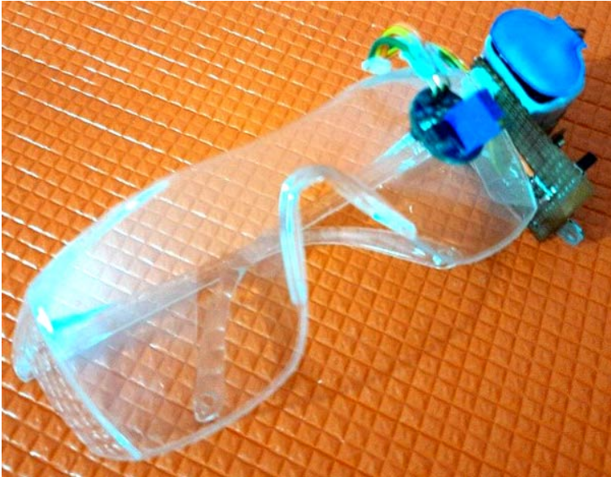

**Model**

The eye blink sensor is used to detect the eye blinks and using which we can also detect the activities like the Drowsiness of the driver while driving. It works based on the technology of Infrared LED. It contains an Infrared transmitter and Receiver LED which is used to detect the eye blink. The working of the simple IR sensor is shown as below:

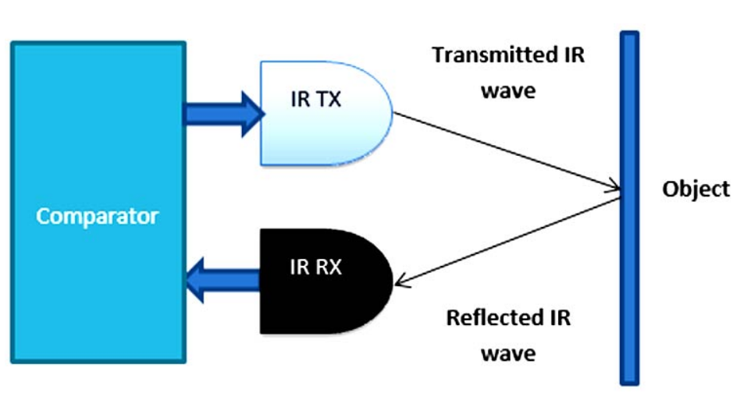

As shown in the image above, infrared sensors consist of two elements: infrared transmitter which acts as the source, and infrared receiver which acts as the receiver. Infrared sources include an IR LED and Infrared detectors include photodiodes. The energy emitted by the infrared source is reflected by an object and falls back on the infrared detector. When the light emitted by the IR LED falls on the receiver, the resistance of the photodiode falls down significantly. This photoreceiver is connected with a potentiometer to form a voltage divider circuit, which gives a variable analog output when blinking activity is detected.

When the incident radiation is more on the photodiode, the voltage drop across the series resistor/Potentiometer will be high. In the Comparator IC which is nothing but an Operational Amplifiers, or Op-amps, both the reference analog voltage and the actual output voltages are compared. If the voltage across the resistor series to photodiode is greater than that of the reference voltage, the output of the comparator is high, else Low. As the output of the comparator is connected to an LED, it glows when the sensor detects some activity such as eye blinking. The threshold voltage can be adjusted by adjusting the potentiometer depending on the environmental conditions.

**Commands used for this project**

//eye Blink by Technical Gudachari

#define SENSE A0

void setup()

{

pinMode(SENSE, INPUT);

pinMode(2, OUTPUT);

pinMode(LED_BUILTIN, OUTPUT);

}

void loop()

{

if(digitalRead(SENSE))

{

digitalWrite(LED_BUILTIN, LOW);

pinMode(2, LOW);

}

else

{

digitalWrite(LED_BUILTIN, HIGH);

pinMode(2, HIGH);

}

}

**Results**

The results for several conditions were calculated and tested to achieve high accuracy.

These conditions vary from person to person, with a person under observation having their eyes closed or open. The person could be someone who wears spectacles due to which might cause reflection of light and result in a glared image, making it difficult for feature extraction and feature selection.

So, to avoid these hindrances, the proposed model was tested against the above-mentioned constraints as well to achieve satisfactory results